LINEAR REGRESSION WITH NUMPY AND PYTHON

A PROJECT REPORT

Submitted by

MEENALOSHINI.D
(Reg. No: 19S018 )

of

5 Year Integrated M.Sc., (Data Science)

in

DEPARTMENT OF APPLIED MATHEMATICS AND COMPUTATIONAL SCIENCE

THIAGARAJAR COLLEGE OF ENGINEERING
(A Govt. Aided Autonomous Institution
affiliated to Anna University)

MADURAI – 625015

June 2020

THIAGARAJAR COLLEGE OF ENGINEERING, MADURAI

DEPARTMENT OF APPLIED MATHEMATICS AND
COMPUTATIONAL SCIENCE

BONAFIDE CERTIFICATE

Certified that this project report “LINEAR REGRESSION WITH NUMPY AND PYTHON ” is the bonafide work of MEENALOSHINI (19S018), Second Semester student of 5 Year Integrated MSc (Data Science) Degree Programme, who carried out the project under my supervision from 17.06.2020 to 30.06.2020 during the academic year 2019-2020.

The project report was submitted to the department on 30/06/2020 for evaluation/assessment.

<sign>
<sign>

Dr.D.Anitha
Project Guide
Assistant Professor in Data Science
Department of Applied Mathematics and Computational Science

Dr. S. Parthasarathy
Professor & Head
Department of Applied Mathematics and Computational Science

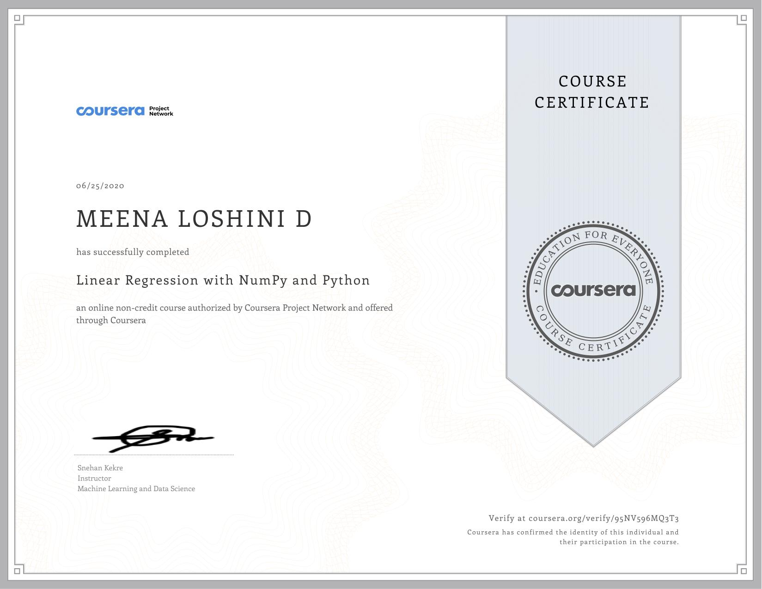

TABLE OF CONTENTS

Page No
- Introduction 6
- Objective of the Project 7
- Description of the Project 8
- Implementation 10
- Significance of the project 14
- Conclusion 16
- Appendices, if any -
- Project Worksheet / Diary 17

LIST OF TABLES
Table Index | Name of the Table | Page No
- | - | -

LIST OF FIGURES
Figure Index | Title of the Figure | Page No
4.1 | Graphical visualization of input data | 10
4.2 | Plot showing the cost over a 2-dimensional grid of 𝜃₀ and 𝜃₁ values | 12
4.3 | Graph showing the variance of cost function with the number of iterations | 12
4.4 | The linear fit | 13

LIST OF ABBREVIATIONS
S.No. | Abbreviation/  Acronym | Description
1. | NumPy | Numerical Python

- Introduction:

Linear regression is a basic predictive analytics technique that uses

historical data to predict an output variable. It is popular for predictive modelling

because it is easily understood and can be explained using plain English.

Linear regression models have many real-world applications in an array of

industries such as economics (e.g. predicting growth), business (e.g. predicting

product sales, employee performance), social science (e.g. predicting political

leanings from gender or race), healthcare (e.g. predicting blood pressure levels from

weight, disease onset from biological factors), and more.

Understanding how to implement linear regression models can unearth

stories in data to solve important problems. We’ll use Python as it is a robust tool to

handle, process, and model data. It has an array of packages for linear regression

modelling.

The basic idea is that if we can fit a linear regression model to observed data,

we can then use the model to predict any future values. For example, let’s assume

that we have found from historical data that the price (P) of a house is linearly

dependent upon its size (S) .

- Objective of the Project
To Create a best fit line between population and profit using the 3 steps given below:

1.Implement the gradient descent algorithm from scratch.
2.Perform univariate linear regression with Numpy and Python.
3.Create data visualizations and plots using matplotlib.
The given dataset has data about population and profit. It contains 97 data points.
The profit is used as the target variable(dependent variable) and population as the
independent variable.
Find the value of Profit on being know the Population or Profit been know
the Population.Based on the input Data any such related Information can be found.

The main idea behind the tasks for the univariate regression is to understand how ad which underlying formulas are applied in single -line functions, which immediately evaluate the regression model parameters and output them along with other values and test statistics.

In other words, the end goal of the Univariate Regression is to not only be able to apply the functions to estimate the models but also understand what(most of) the presented values say about the model.

- Description of the Project:

Python is used since it emphasis on code readability, and its syntax allows

programmers to express their concepts in fewer lines of code.

It is used due to its Extensive support libraries(NumPy for numerical

calculations, Pandas for data analytics etc). All these libraries helps in giving a

graphical representation and making the work simpler..due to inbuilt libraries no need

of external coding on each step.

Pandas is the library used to store huge set of data in the form of data

frames. Matplotlib has a great number of commands which can be used to visualize

the given data in the form of graphs, scatterplots, etc. Numpy is one of the best data

storage libraries in Python.

- Gradient Descent:

The gradient descent method (GDM) is also often referred to as “steepest

descent” or the “method of steepest descent”. As the name suggests GDM utilizes the

steepest gradient in order to search for an optimum, i.e. maximum or minimum, point

for any given function.

In linear regression, the model targets to get the best-fit regression line to

predict the value of y based on the given input value (x). While training the model,

the model calculates the cost function which measures the Root Mean Squared error

between the predicted value (pred) and true value (y). The model targets to minimize

the cost function.
To minimize the cost function, the model needs to have the best value of

θ₁ and θ₂. Initially model selects θ₁ and θ₂ values randomly and then iteratively

update these value in order to minimize the cost function until it reaches the

minimum. By the time model achieves the minimum cost function, it will have the

best θ₁ and θ₂ values. Using these finally updated values of θ₁ and θ₂ in the

hypothesis equation of linear equation, model predicts the value of x in the best

manner .
Therefore, the question arises – How θ₁ and θ₂ values get updated ?
Linear Regression Cost Function:

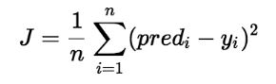

Gradient Descent Algorithm For Linear Regression:

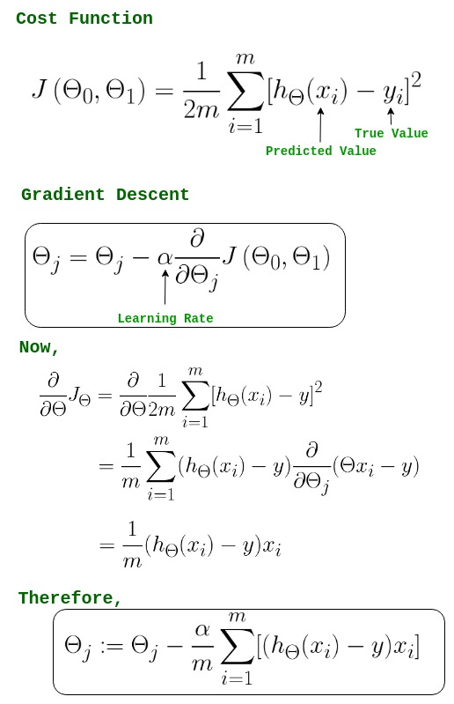

- Implementation
a)The data is loaded and libraries are imported:

import matplotlib.pyplot as plt
plt.style.use('ggplot')
%matplotlib inline
import numpy as np
import pandas as pd
import seaborn as sns
plt.rcParams['figure.figsize'] = (12, 8)
data = pd.read_csv("food_truck_data.txt")
data.head()
data.info()

b)Visualize the data set:

ax = sns.scatterplot(x='Population', y='Profit', data=data)
ax.set_title("Profit in $10000s vs City Population in 10000s");

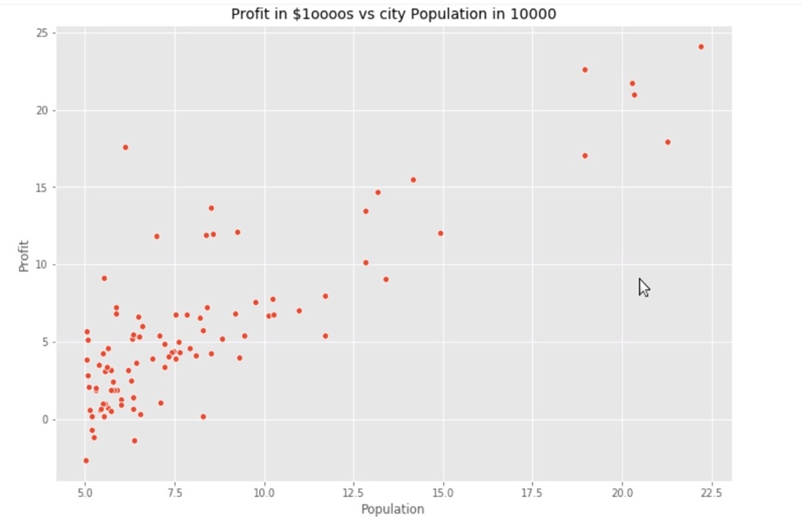
Fig 4.1:Graphical visualization of input data

c)Compute the Cost 𝐽(𝜃):

Gradient Descent method is used to perform linear regression. The aim of
linear regression is to estimate the parameters by minimizing the cost function J(𝜃). The cost is nothing but the sum of the squares of the errors that the model made in estimating the parameters.

def cost_function(X, y, theta):
m = len(y)
y_pred = X.dot(theta)
error = (y_pred - y) ** 2
return 1 / (2 * m) * np.sum(error)
m = data.Population.values.size
X = np.append(np.ones((m, 1)), data.Population.values.reshape(m, 1), axis=1)
y = data.Profit.values.reshape(m, 1)
theta = np.zeros((2,1))
cost_function(X, y, theta)

d)Implement Gradient Descent:

Gradient descent is used to minimize a cost function J(W) parameterized by a model parameters W.The gradient (or derivative) tells us the incline or slope of the cost function.

def gradient_descent(X, y, theta, alpha, iterations):
m = len(y)
costs = []
for i in range(iterations):
y_pred = X.dot(theta)
error = np.dot(X.transpose(), (y_pred - y))
theta -= alpha * 1/m * error
costs.append(cost_function(X, y, theta))
return theta, costs

theta, costs = gradient_descent(X, y, theta, alpha=0.01, iterations=1000)
print("h(x) = {} + {}x1".format(str(round(theta[0, 0], 2)),
str(round(theta[1, 0], 2))))

d)Visualization the cost function J(𝜃):

Cost Function quantifies the error between predicted values and expected values and presents it in the form of a single real number.

from mpl_toolkits.mplot3d import Axes3D

theta_0 = np.linspace(-10,10,100)
theta_1 = np.linspace(-1,4,100)
cost_values = np.zeros((len(theta_0), len(theta_1)))
for i in range(len(theta_0)):
for j in range(len(theta_1)):
t = np.array([theta_0[i], theta_1[j]])
cost_values[i, j] = cost_function(X, y, t)
fig = plt.figure(figsize = (12, 8))
ax = fig.gca(projection = '3d')
surf = ax.plot_surface(theta_0, theta_1, cost_values, cmap = "viridis", linewidth = 0.2)
fig.colorbar(surf, shrink=0.5, aspect=5)
plt.xlabel("$\Theta_0$")
plt.ylabel("$\Theta_1$")
ax.set_zlabel("$J(\Theta)$")
ax.set_title("Cost Surface")
ax.view_init(30,330)
plt.show()
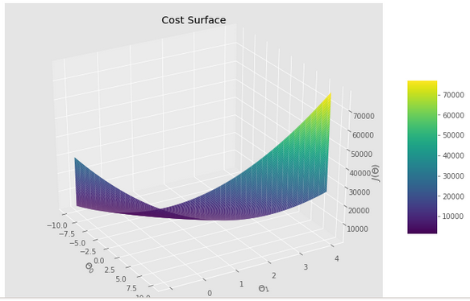
Fig 4.2: Cost over a 2-dimensional grid of 𝜃₀ and 𝜃₁ values

e)Plotting the convergence:
plt.plot(costs)
plt.xlabel("Iterations")
plt.ylabel("$J(\Theta)$")
plt.title("Values of Cost Function over iterations of Gradient Descent");
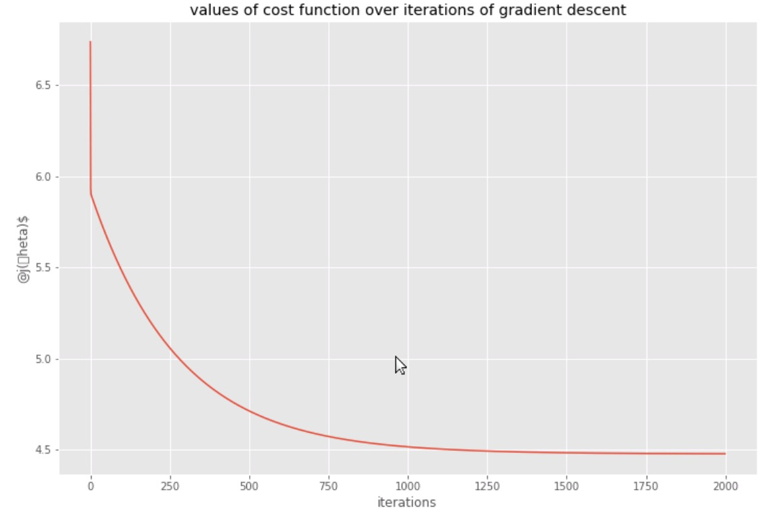
Fig 4.3: Variance of cost function with the number of iterations.

f)Training Data with Univariate Linear Regression Fit:

theta.shape

theta = np.squeeze(theta)
sns.scatterplot(x = "Population", y= "Profit", data = data)
x_value=[x for x in range(5, 25)]
y_value=[(x * theta[1] + theta[0]) for x in x_value]
sns.lineplot(x_value,y_value)
plt.xlabel("Population in 10000s")
plt.ylabel("Profit in $10,000s")
plt.title("Linear Regression Fit");

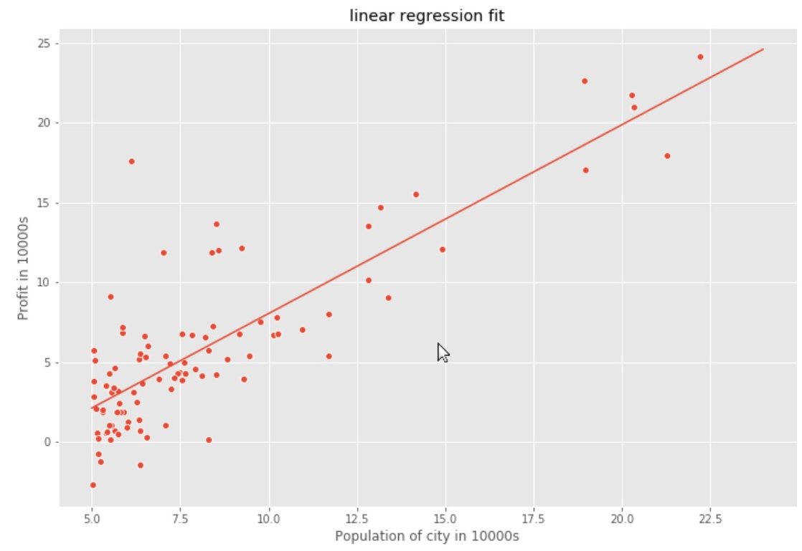
Fig 4.4: The linear fit

This can be used to find the profit for any given population and the cities to open branches in order to get the expected profit using the about graph obtained using linear regression.

- Significance of the project :
A linear regression model predicts the target as a weighted sum of the
feature inputs. The linearity of the learned relationship makes the interpretation
easy. Linear regression models have long been used by statisticians, computer
scientists and other people who tackle quantitative problems.
Linear models can be used to model the dependence of a regression target y
on some features x. The learned relationships are linear and can be written for a
single instance i as follows:
y=β0+β1x1+…+βpxp+ϵ

The biggest advantage of linear regression models is linearity: It makes the

estimation procedure simple and, most importantly, these linear equations have an

easy to understand interpretation on a modular level (i.e. the weights).

This is one of the main reasons why the linear model and all similar models

are so widespread in academic fields such as medicine, sociology, psychology, and

many other quantitative research fields. For example, in the medical field, it is not

only important to predict the clinical outcome of a patient, but also to quantify the

influence of the drug and at the same time take sex, age, and other features into

account in an interpretable way.

Benefit:

When the company decides to open a new branch in a city, they can find out the

expected profit (assuming the city population is known) using this regression

line.Also, they will be able to find out the cities in which they should open branches in

case of a specific target profit.

Challenges:

Linear regression technique outliers can have huge effects on the regression

and boundaries are linear in this technique.

Diversely, linear regression assumes a linear relationship between dependent

and independent variables. That means it assumes that there is a straight-line

relationship between them. It assumes independence between attributes.

But then linear regression also looks at a relationship between the mean of the

dependent variables and the independent variables. Just as the mean is not a

complete description of a single variable, linear regression is not a complete

description of relationships among variables.

To sum up,

Linear Regression is a great tool to analyze the relationships among the

variables but it isn’t recommended for most practical applications because it over-

simplifies real-world problems by assuming a linear relationship among the variables.

This has a lot of real life applications….which adds up to its benefits..

Linear regressions can be used in business to evaluate trends and make

estimates or forecasts. For example, if a company’s sales have increased steadily

every month for the past few years, by conducting a linear analysis on the sales data

with monthly sales, the company could forecast sales in future months.

used to analyze the marketing effectiveness, pricing and promotions on sales of

a product. For instance, if company XYZ, wants to know if the funds that they have

invested in marketing a particular brand has given them substantial return on

investment, they can use linear regression. The beauty of linear regression is that it

enables us to capture the isolated impacts of each of the marketing campaigns along

with controlling the factors that could influence the sales.

used to assess risk in financial services or insurance domain. For example, a car

insurance company might conduct a linear regression to come up with a suggested

premium table using predicted claims to Insured Declared Value ratios. The

results of such an analysis might guide important business decisions.

- Conclusion:

Thus Linear Regression for the given dataset was performed by the Gradient

Descent method. Using Python code the best fit line was found. This can be used to

find the profit for any given population.

The parameters for the regression line were found and the plots were made as

shown in the implementation part. Linear regression provides the significance level of

each attribute contributing to the prediction of the dependent variable.

As future work, multivariate linear regression can be also performed by taking

more than one independent variable.

7. Project Worksheet / Diary :
WEEK 1 | Date | Topics learned / Activity carried out / Task completed / Online /E-resources accessed
WEEK 1 | 17.06.2020 | Basic topics needed for the project like gradient descent.
WEEK 1 | 18.06.2020 | Libraries usage and a getting to know more about them.
WEEK 1 | 19.06.2020 | Started the coding.Introduction and importing the libraries and data.
WEEK 1 | 20.06.2020 | Visualize the data and computing the cost
WEEK 1 | 21.06.2020 | Implementation of gradient descent
WEEK 1 | 22.06.2020 | visualizing the cost function

WEEK 2 | Date | Topics learned / Activity carried out / Task completed / Online /E-resources accessed
WEEK 2 | 23.06.2020 | Plotting the convergence
WEEK 2 | 24.06.2020 | Training data with linear regression.
WEEK 2 | 25.06.2020 | Inference using the optimized value and completion of coding
WEEK 2 | 26.06.2020 | Report generation
WEEK 2 | 27.06.2020 | Report generation
WEEK 2 | 28.06.2020 | Report generation

Signature of the Student Signature of the faculty guide
(with date) (with date)

XXXX

